*TDLR eInspection Applications.*



Technical Design Document



***Prepared for***

Texas Department of Licensing and Regulation

06/22/2022

Version 2.0

***Prepared by:***

Microsoft



Technical Design Document



Revision Sheet

Change Record

|  |  |  |  |
| --- | --- | --- | --- |
| Date | Author | Version | Change Reference |
| 03/15/2022 | Daisy Wilke | 1.0 | Initial draft |
| 6/22/2022 | Daisy Wilke | 2.0 | Final Draft |

Review Record

|  |  |  |  |
| --- | --- | --- | --- |
| Date | Author | Version | Change Reference |
| 03/15/2022 | Matthew Jeroue | 1.0 | Initial draft |

Table of Contents

*1.* Introduction 6

1.1 Reference Documents 6

1.2 Actors 6

1.3 Abbreviations and Glossary of Terms 6

*2.* High Level Solution Design 7

2.1 Design Overview 8

2.2 Design Considerations 9

*3.* Power Apps and Dataverse 10

3.1 Entity Relationship and Data Model 10

3.2 Entities 10

3.3 Global Option Sets 11

3.4 Processes 11

3.5 Web Resources 13

3.6 Plugins 13

*4.* Model-driven App 14

4.1 Dashboards 16

4.2 Licensees and Workplans 16

4.3 Proof of Inspections 17

4.4 Administration 17

*5.* Canvas App 18

5.1 Canvas App screens – Search Licensee 18

5.2 Canvas App screens – My in Progress Inspections 19

5.3 Canvas App screens – Inspection History 19

5.4 Canvas App screens – Licensee Information 20

4.5. Canvas App screens – Create an Inspection 20

5.0 Power Automates (Flows) 24

5.1 Copy file from Sharepoint to onedrive 25

5.2 Copy Signature from User Record 25

5.3 Generate Complaint Report for Inspector Review 25

5.4 Generate Enforcement PDF 25

5.5 Inspection On Submit Send POI PDF 25

5.6 Region Update Regional Manager on user record 25

5.7 Request Approval for DTE - Complaint 25

5.8 Request Approval for DTE - POI 25

5.9 Send Complaint Report Information 25

5.9 Send Email to the Inspector when Approved or Corrections Needed – Complaint 25

5.10 Send Email to the Inspector when Approved or Corrections Needed – POI 26

5.11 Set Modern Approval to Complete if Approved - Complaint 26

5.12 Set Modern Approval to Complete if Approved – POI 26

*6.* Templates 26

*7.* Dataflows 27

*8.* Appendix A: 28

8.1 Error Logging 28

System job 28

Flow run history. 29

*9.* Appendix B: Dataflows for 2 way integration between Power Platform to and from VERSA and Tulip 31

9.1 Connect from Tulip to Power Platform eInspections 32

9.2 Connect from VERSA to Power Platform eInspections 34

9.3 Exporting Data from eInspections 36

9 Appendix B: References 38

9.1 Tools 38

9.2 Dynamics CE/ Dataverse 39

# Introduction

This Technical Design Document (TDD) describes the technical implementation of the requirements specified in the requirements documents. This TDD describes the following functionality of the MyOAP Client Online Tool implementation.

* Detailed Technical Design of PowerApps Model Driven App configuration and customization.
* Detailed Design and Technical implementation of the Power Apps Canvas Apps.
* Detailed Design and Technical implementation of Power Automate processes.

## Reference Documents

|  |  |  |
| --- | --- | --- |
| ID | Reference | Document |
| [R1] | Architectural Doc |  |
| [R2] | Business Requirement Doc |  |
| [R3] | Deployment Document |  |
|  |  |  |

## Actors

***Inspectors***: Inspectors are agents of the state that are ensuring that Facilities and Individuals that are licensed with a Massage License are complying with the applicable laws and regulations. The inspections are conducted in person, virtually or as a desk audit. Inspectors captures details of the inspection using the eInspection app and the Licensee get a proof of inspection document.

***ATU***: Anti-trafficking unit work together with inspectors and when they receive notification of suspected HT they conduct their own investigation and inspection

***Admin***: Admins update Violations and master data for the program

## Abbreviations and Glossary of Terms

| **Abbreviation** | **Explanation** |
| --- | --- |
| Dynamics 365 CE | Dynamics 365 Customer Engagement also known as “Dynamics CRM” or “CRM” |
| SDD | Solution Design Document |
|  |  |
|  |  |

# High Level Solution Design

The overall eInspection solution can be decomposed into the following 3 areas:

* A Power Apps Canvas application to capture inspections on a mobile app
* A Power Apps model-driven app for Inspections that is optimized for the desktop
* Power Automate(flows) to support TDLR Processes



Figure 1. eInspection Solution Architecture Diagram

The below section talks about the high-level Design Overview and Design Considerations.

## Design Overview

***Power Apps Model Driven App and Dataverse:***  Implementation of Power Apps core configurations and any custom code and workflows were implemented for each entity in the system and are captured in this document.

***Power Apps Canvas App***: eInspection Mobile app that is optimized for iOS iPhone and iPad

***Power Automates:*** implementation of different power automates for eInspection. They are mainly used to for notifications and to generate documents

## Design Considerations

This section defines the design consideration for the implementation in the technical

***Use of Dataverse OOB and custom entities.***

* OOB Account Entity is used to capture Licensee Information
* OOB offline capabilities
* OOB Auditing

***Use of PowerAutomate and Out of the Box connectors***

Use of OneDrive connector to generate PDF from Word Templates

Use of Word Online for Templates

Use of SSRS for Enforcement Reports

***Portrait Canvas App***

* Out of the box portrait canvas app
* Use of containers to the app to render on tablets

# Power Apps and Dataverse

This section describes the technical implementation of dataverse and model driven app components such as tables, workflows, business rules, webresources that were developed to implement the functional requirement defined in each use case.

## Entity Relationship and Data Model

Below is a visual representation of the key dataverse tables for the eInspection App.

Refer to the Entity Metadata doc(R1) for more details on table fields and relationships

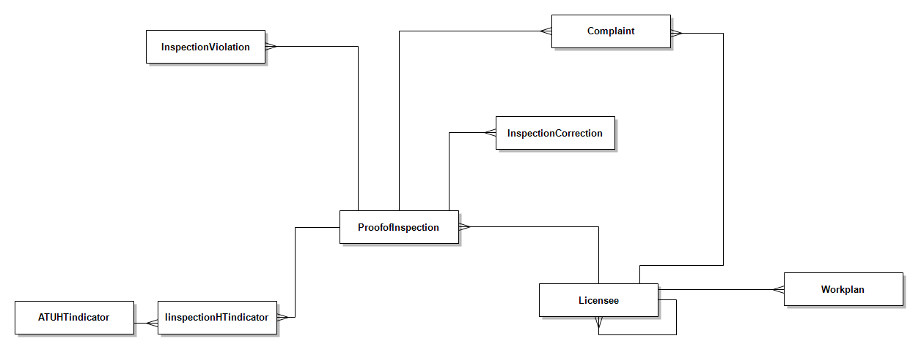

Figure 2 eInspection Entity Relationship Diagram

## Entities

| Display name | Name | Purpose |
| --- | --- | --- |
| Licensee/Facilities | account | OOB Account entity used to capture Licensee Information |
| Proof of Inspection | tdlr_proofofinspection | Custom table to record details of an inspection |
| Violation/Statute | tdlr_statute | Custom table that has master data for all MAS violations |
| Complaints | tdlr_complaints | Custom table to record complaints against an individual or business |
| Workplan | tdlr_workplan | Custom table that has inspection schedule of the Licensee |
| Inspection Violation | tdlr_inspectionviolation | Custom table with violation for a particular inspection |
| License Type | Tdlr_LicenseType | Custom Table that has master data of License Type |
| User | user | OOB table with inspectors and other users information |
| Region | Tdlr_region | Custom table with TDLR’s regions |
| County | Tdlr_county | Custom table with TX counties |

## Global Option Sets

We create global option sets if we think same option is going to be used in multiple entities

|  |  |  |
| --- | --- | --- |
| Display Name | Name | purpose |
| Establishment Type | Tdlr_establishmenttype | Type of establishment: individual or Facility |
| States | Tdlr_states | USA states; default TX |
| License Status | Tdlr_licensestatus | Indicates if the Licensee has a valid license at present |
| Inspection Type | Tdlr_inspectiontype | Store the type of inspection being conducted eg initial, periodic |

## Processes

Below table describes the 23 server-side process/workflows for eInspections with the reference to entity/table.

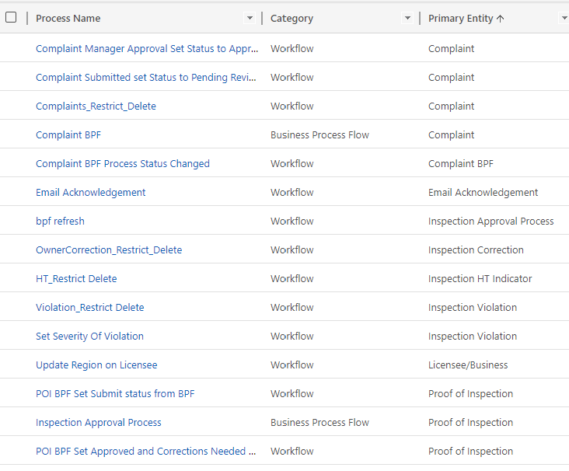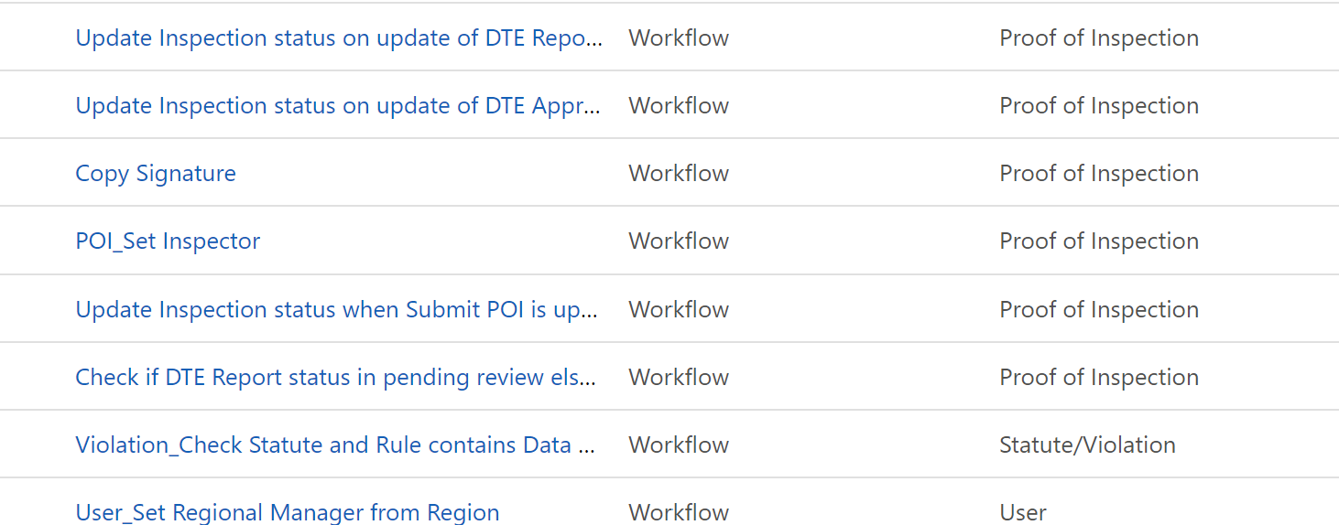

## Web Resources

Below table shows the client side custom code plugin used on different forms in the applications

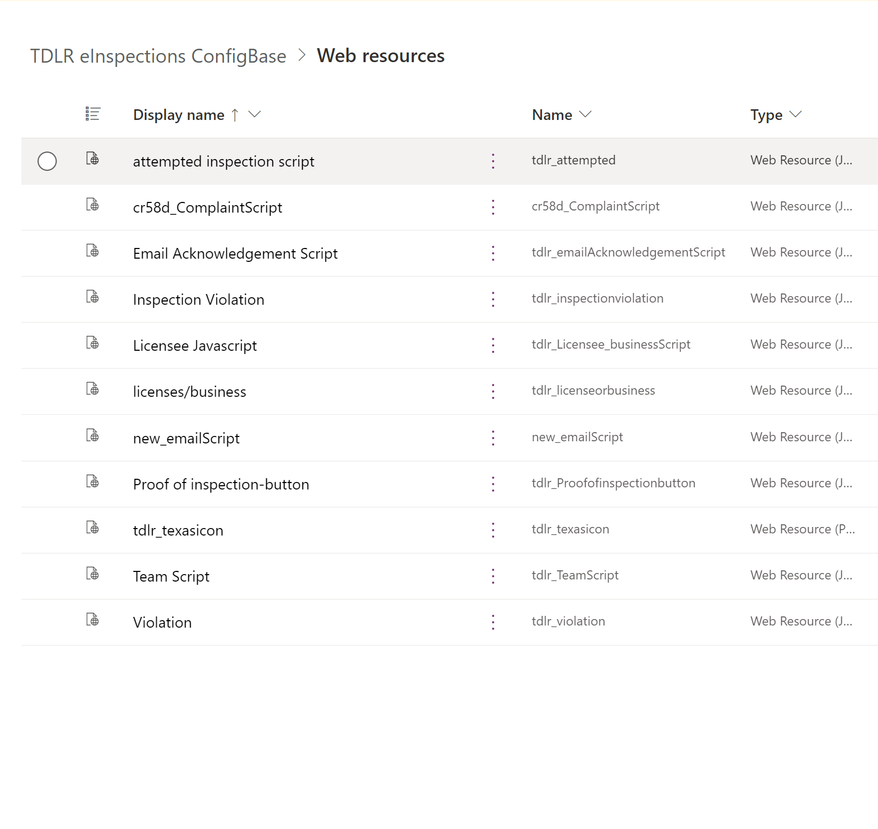

## Plugins

Below table shows the server side custom code plugin used on note entity to compress images as well as to restrict type of attachments that are allowed

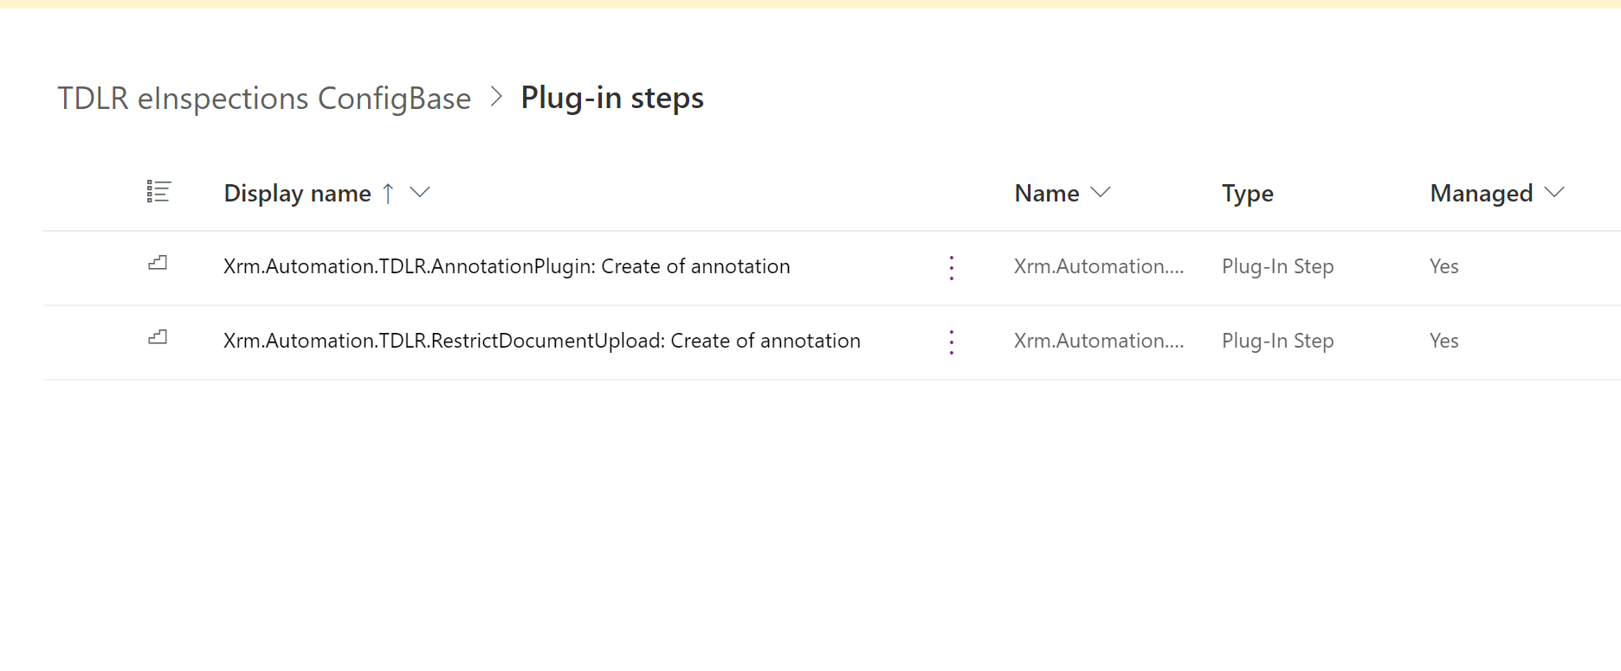

# Model-driven App

Model-driven app design is an approach that focuses on quickly adding components to your apps. These components include dashboards, forms, views, and charts. With little or no code, you can make apps that are simple or complex.

A model-driven app consists of several components that you select by using the App Designer. The components and component properties become the metadata. At a high level the below components can be added:

**Data:** Entities, Fields etc.

**UI**: Sitemap, Form Views etc.

**Logic:** Workflows, Business process flows etc.

**Visualization:** Charts, Dashboards etc.

The Model driven App for eInspections is named TDLR eInspections

**Note**: Its part of TDLR_POCConfigbase solution, App Name: TDLR eInspections

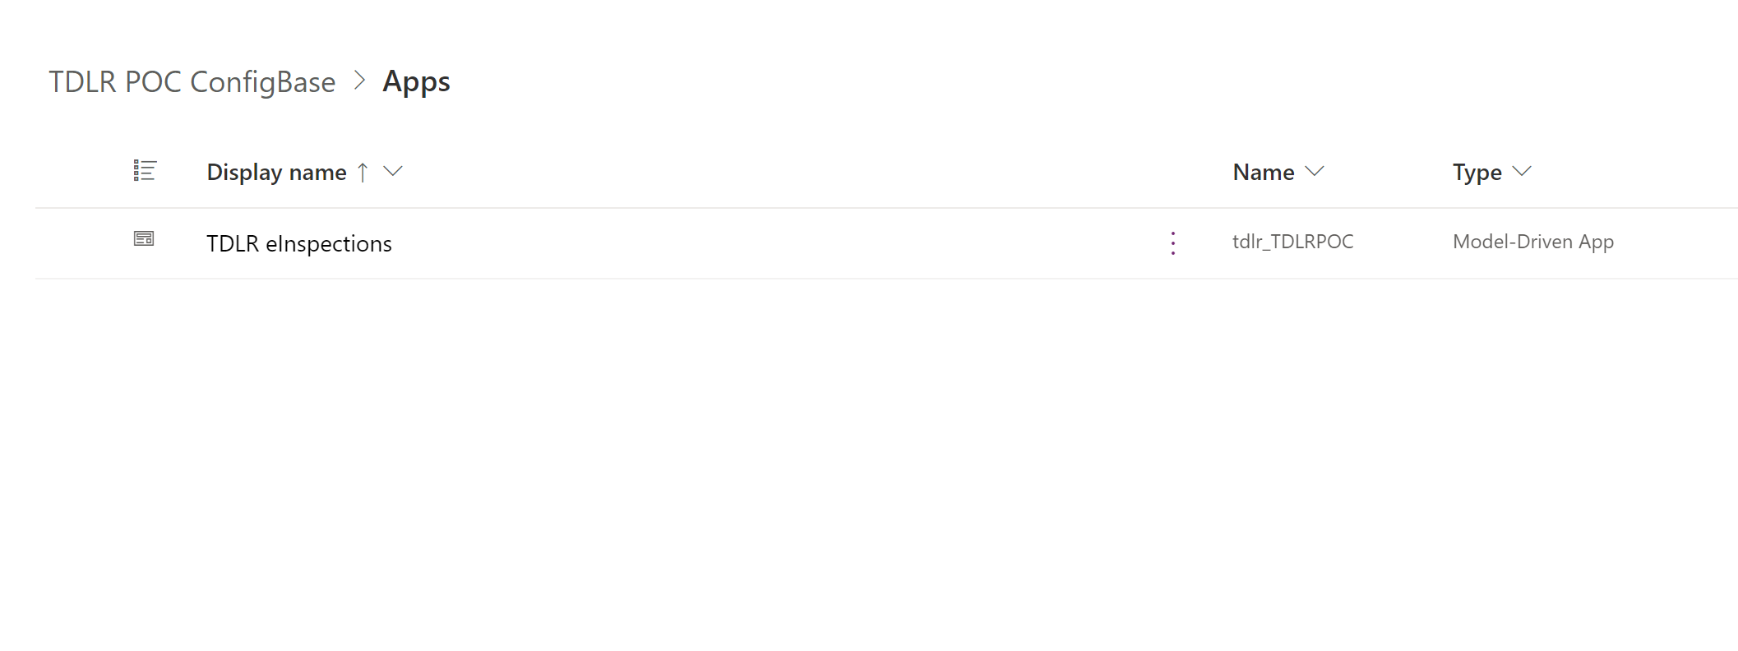

Figure 3 eInspection Model Driven App

From PowerApps maker portal to navigate to eInspections App to view business entities like Licensee, Proof of Inspections, Violations etc do the following:

* Make.powerapps.gov.us ->
* Apps ->

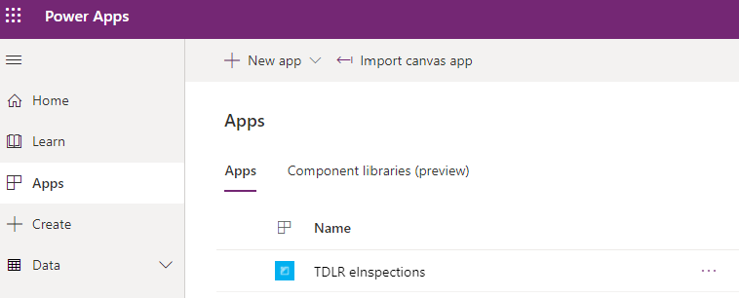

Figure 4 eInspection App in the maker portal

* TDLR eInspections

## Dashboards

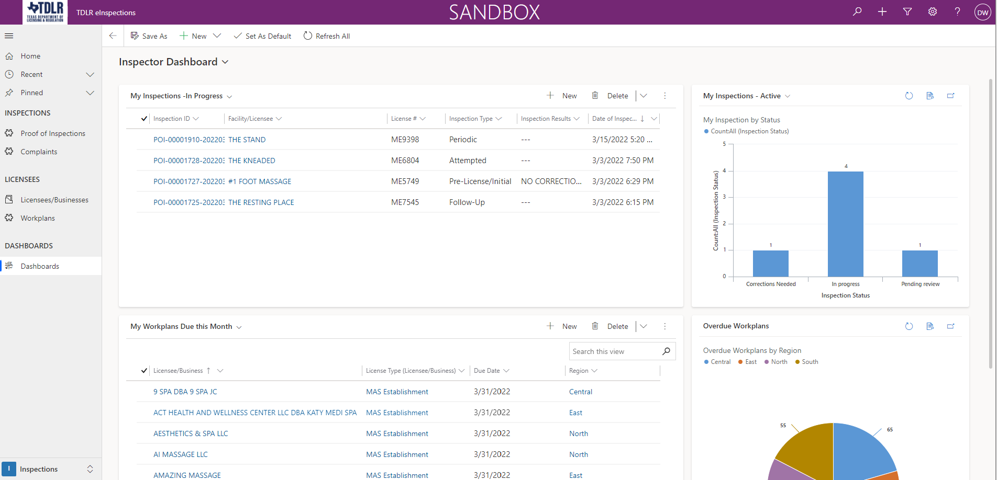

## Licensees and Workplans

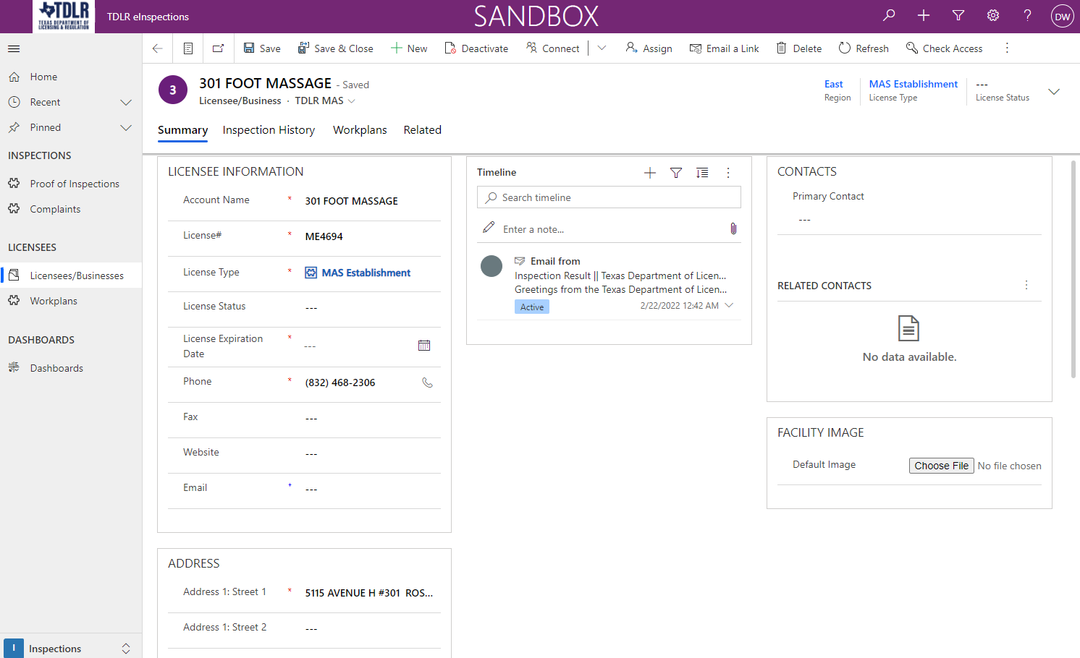

## Proof of Inspections

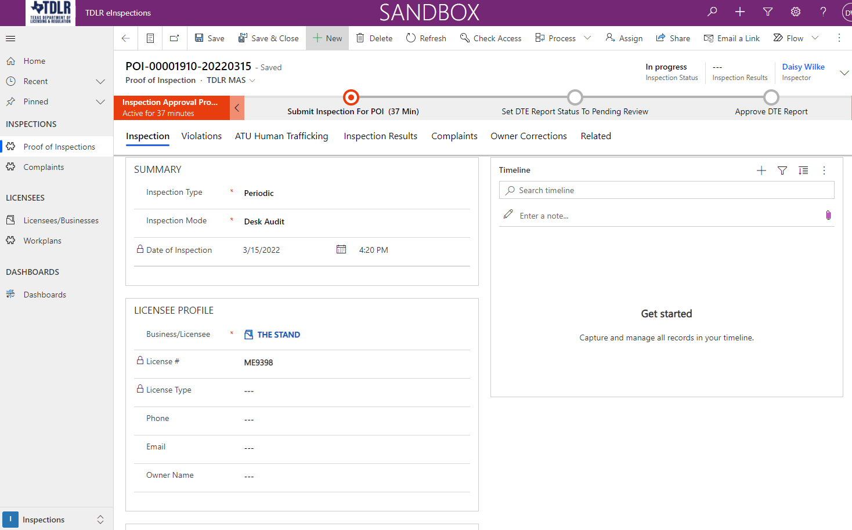

## 4.4 Administration

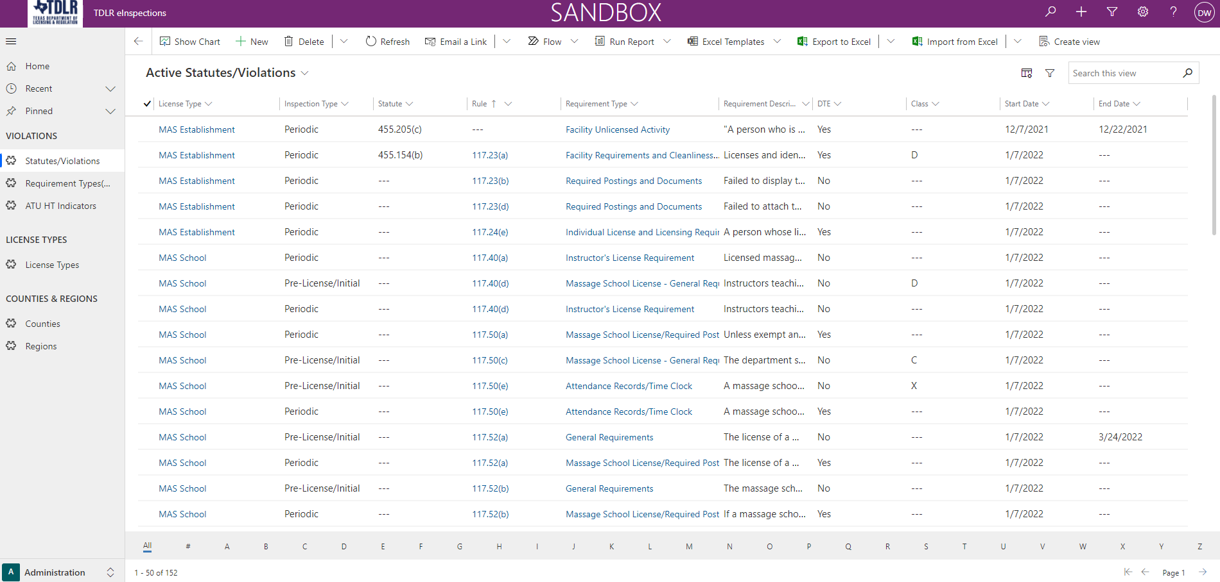

# Canvas App

The Canvas App for eInspections is named TDLR eInspections Mobile

From PowerApps maker portal to navigate to eInspections Mobile App do the following:

* Make.powerapps.gov.us ->
* Apps ->
* TDLR eInspections Mobile

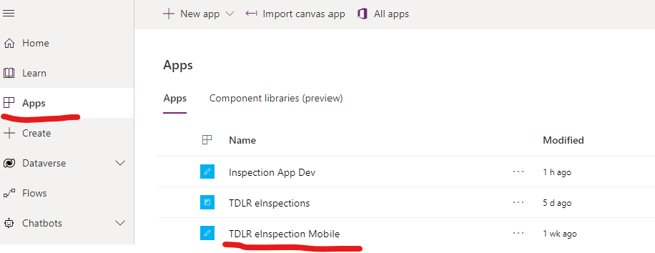

Figure 5 TDLR eInspections Mobile App

## Canvas App screens – Search Licensee

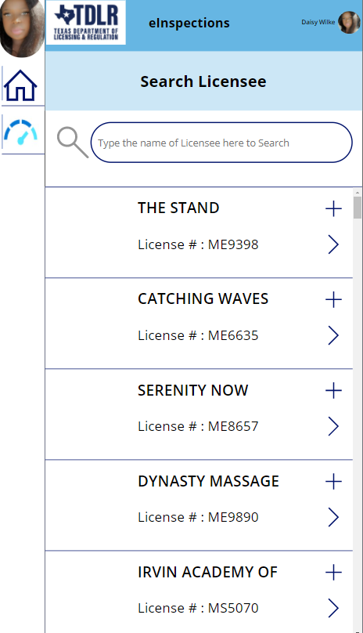

## Canvas App screens – My in Progress Inspections

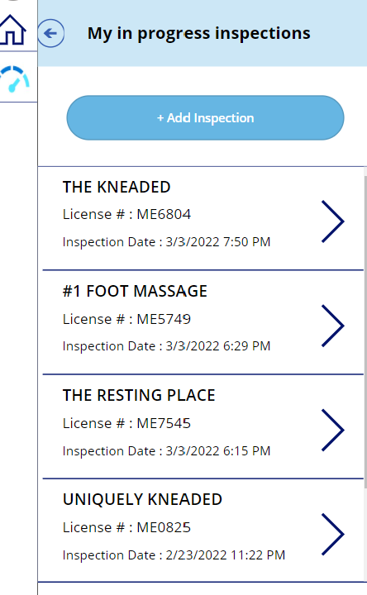

## Canvas App screens – Inspection History

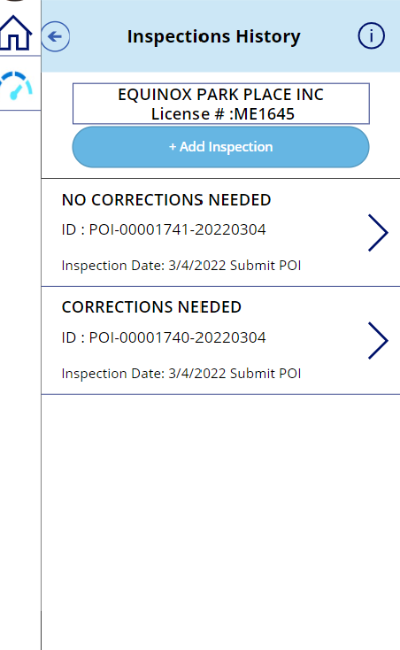

## Canvas App screens – Licensee Information

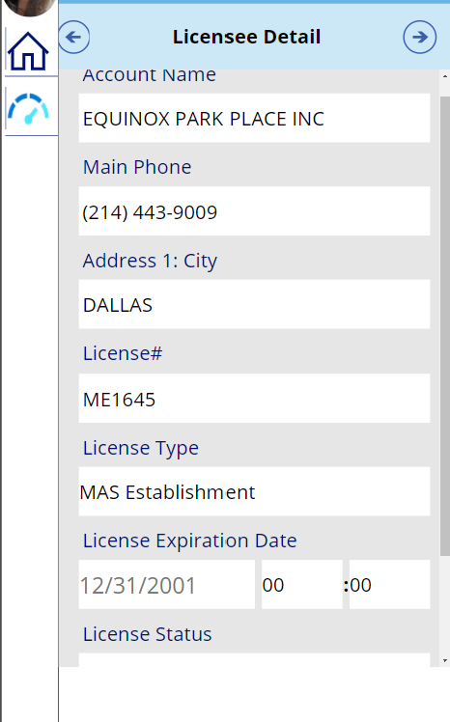

## 4.5. Canvas App screens – Create an Inspection

Screen 1: Enter Inspection Type, Mode, Licensee

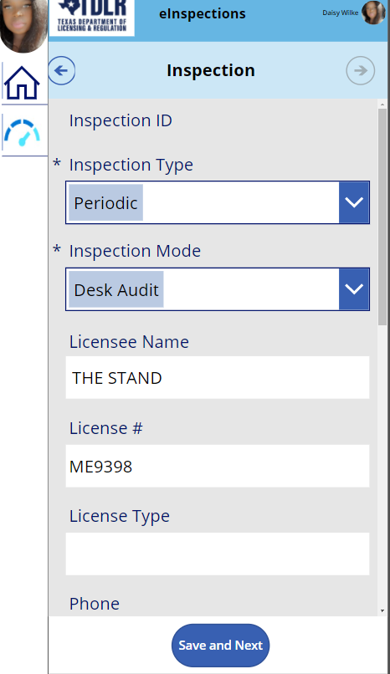

Screen 2: Add Violations

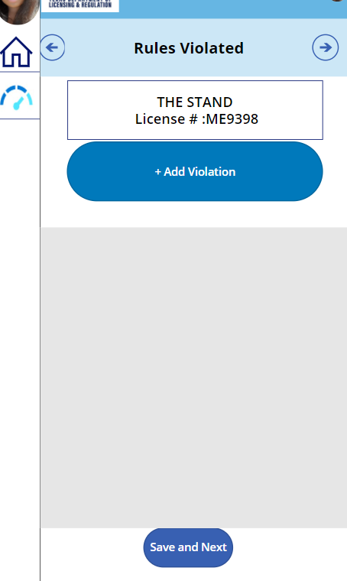

Screen 3: Indicate If HT is present

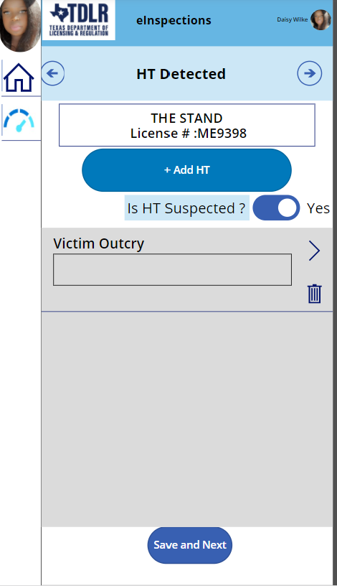

Screen 4: Capture Inspection Signatures, Submit for POI or Save Inspection for Later

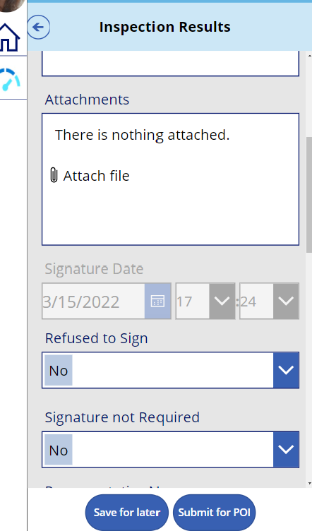

# 5.0 Power Automates (Flows)

Power Automate is an online workflow service that automates actions across the most common apps and services.

We have used power automates for following requirements in eInspections project:

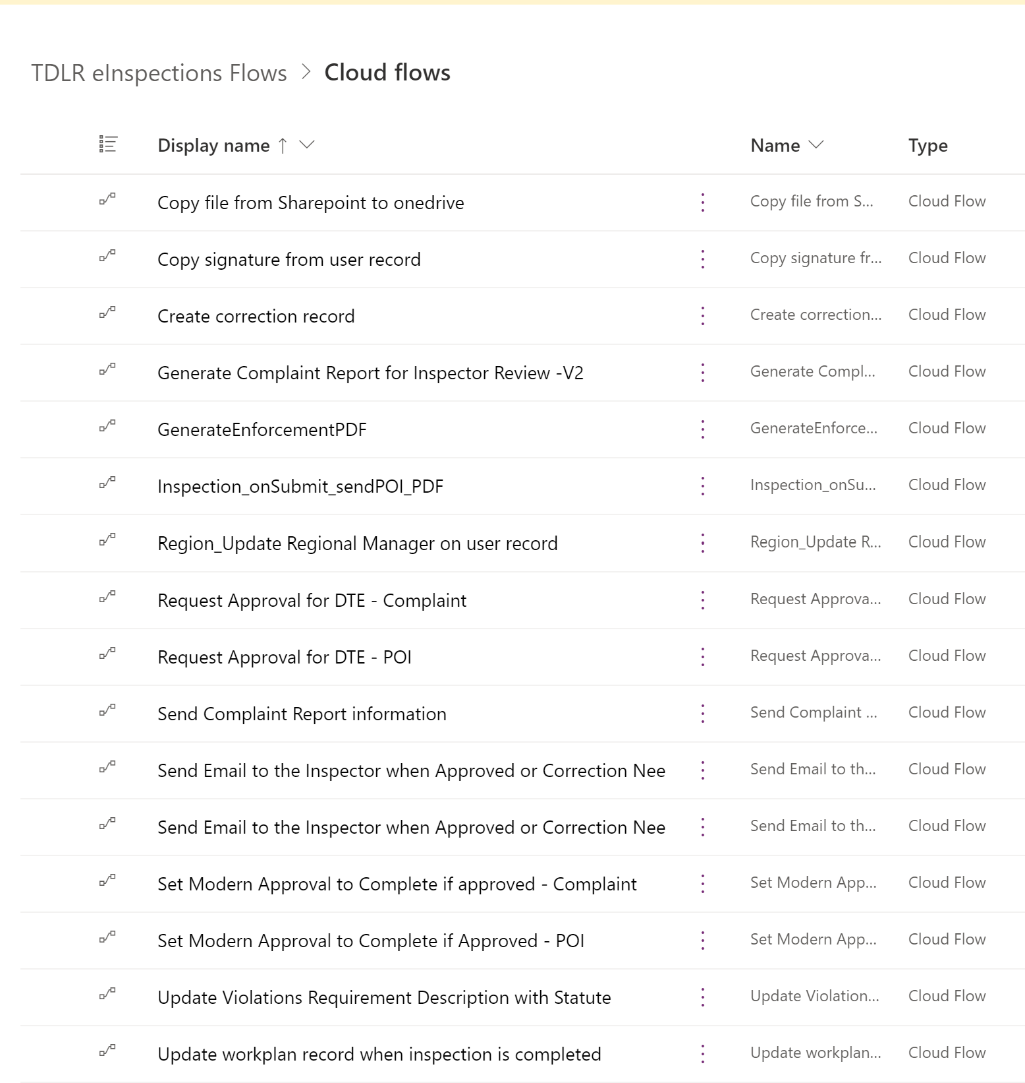

Figure 6 Flows in eInspection

### 5.1 Copy file from Sharepoint to onedrive

Copies VersaExtract and Tulip Extract Files to onedrive location for import into eInspections.

### 5.2 Copy Signature from User Record

When a POI record is created by the user, this will copy the signature from the user record to the POI record. So, the Inspector doesn't need to sign every time on POI record.

### 5.3 Generate Complaint Report for Inspector Review

This flow generates the draft complaint report for the Inspector to review before sending to the regional manager to approve the complaint.

### 5.4 Generate Enforcement PDF

When POI record is approved by the regional manager it generates the enforcement pdf and sends it to the enforcement team. Also, when POI sent for the approval to the regional manager it also generates a draft pdf and attaches on the notes table.

### 5.5 Inspection On Submit Send POI PDF

When POI record is submitted, it calculates the inspection result and send the POI pdf to the customer. Also, if POI record is marked with HT flag indicator, then it will send an email to the ATU team.

### 5.6 Region Update Regional Manager on user record

Every user is tagged with a region and its regional manager. If Regional manager is changed on region record, then it will update the regional manager on the user record of that region.

### 5.7 Request Approval for DTE - Complaint

On a Complaint record, when submitted a Modern Approval will be created and Assigned to the Regional Manager. The Approval will show up in both Teams and via an Email. Once the Modern Approval is Updated to Correction Needed or Approved, then the Complaint record will be updated to reflect the new status.

### 5.8 Request Approval for DTE - POI

On a POI record, when submitted a Modern Approval will be created and Assigned to the Regional Manager. The Approval will show up in both Teams and via an Email. Once the Modern Approval is Updated to Correction Needed or Approved, then the POI record will be updated to reflect the new status.

## 5.9 Send Complaint Report Information

Send Complaint Report to Enforcement for Complaints not associated with a POI

### 5.9 Send Email to the Inspector when Approved or Corrections Needed – Complaint

On a Complaint record, when the status is changed to Approved or Correction Needed an e-mail will be sent to notify the Inspector.

### 5.10 Send Email to the Inspector when Approved or Corrections Needed – POI

On a POI record, when the status is changed to Approved or Correction Needed an e-mail will be sent to notify the Inspector.

### 5.11 Set Modern Approval to Complete if Approved - Complaint

On a Complaint record, from the Model Driven Application in Dynamics 365 CE, if the Manager Approval Status is changed to either Approved or Correction Needed, this flow will find the related existing Modern Approval and update it to completed including the status of the related Complaint record.

### 5.12 Set Modern Approval to Complete if Approved – POI

On a POI record, from the Model Driven Application in Dynamics 365 CE, if the DTE Approval Status is changed to either Approved or Correction Needed, this flow will find the related existing Modern Approval and update it to completed Approval including the status of the related POI record.

# Templates

Templates for POI PDF , Complain PDF and Enforcement PDF are located in **svc_insp_flow’s** OneDrive. These are referenced by the Power Automate and are not to be moved.

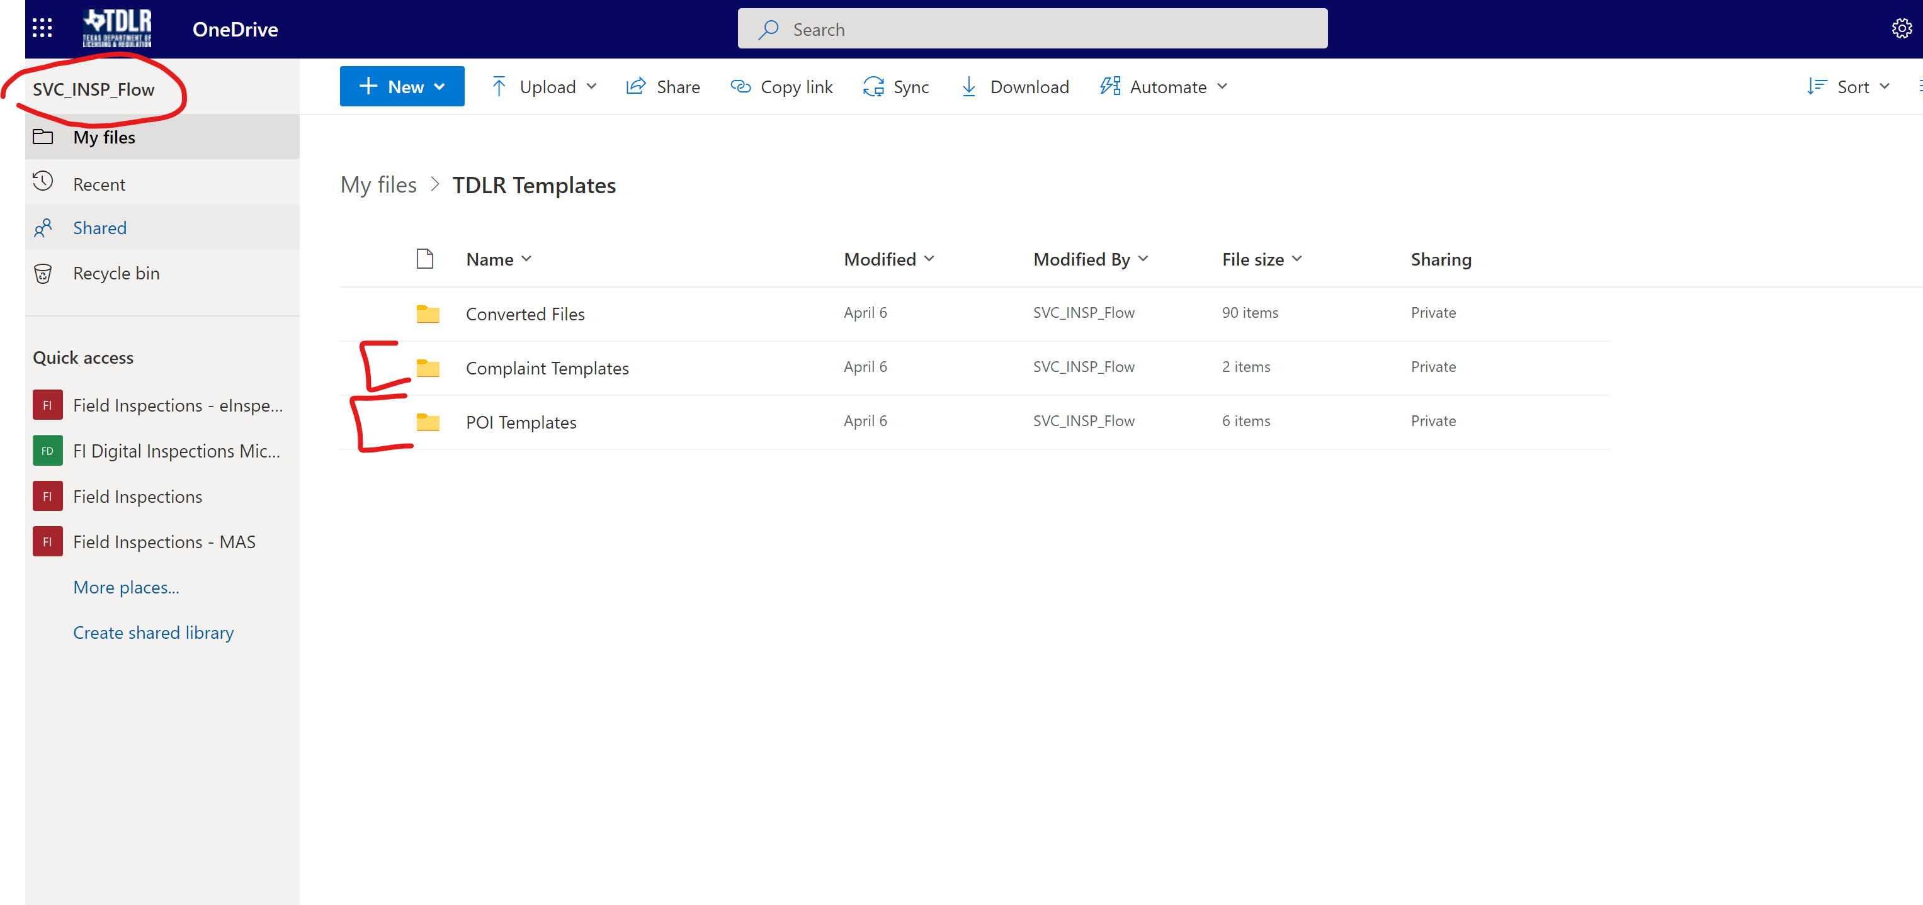

Prior to import into eInspection data extract files are copied to svc_insp_flow’s OneDrive by a power automate flow.

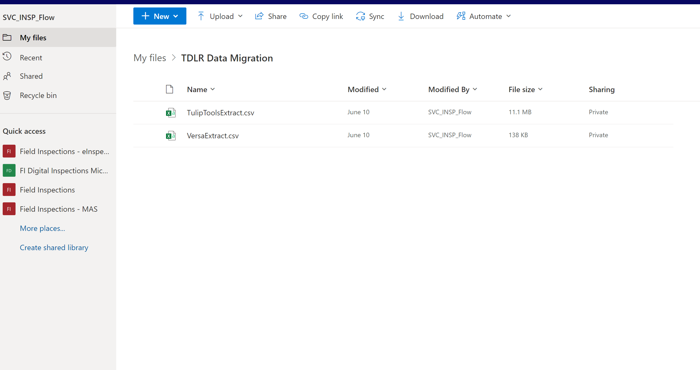

# Dataflows

Dataflows help organizations unify data from disparate sources. Dataflows are being used in the eInspection App to insert and update into eInspection Licensee information from VERSA and TULIP which are their system of record.

Licensee information in eInspection is read only to the users.

There is an initial data migration of all Licensees and a daily update using a scheduled dataflow.

**TulipExtract**: Refreshes every night at 3AM CST

**VersaExtract**: Refreshes every night at 1AM CST

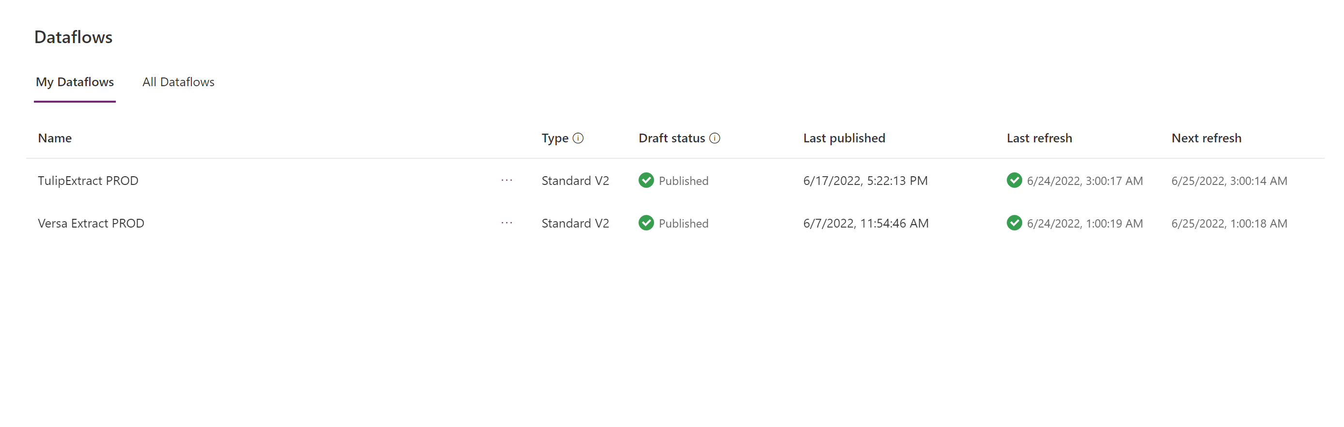

Figure 7 eInspection DataFlows in Production

# Appendix A:

## Error Logging

We are using all the Out of box capabilities to log the errors and exceptions

### System job

For asynchronous registered plug-in or workflows or custom workflow activities that returns an exception, the tracing information is shown in the Details area of the System Job form in the web application.

Background workflows generate System Job records to track their status. You can access information about these system jobs in several places within the application:

**Settings > System Jobs**

This will include all types of system jobs. You will need to filter records to those where System Job Type is Workflow.

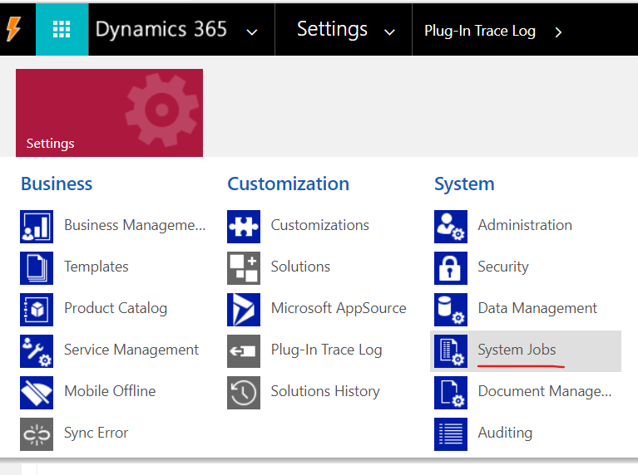

**From the Workflow Process**

Real-time workflows and actions do not use System Job records because they occur immediately. Any errors that occur will be displayed to the user in the application with the heading Business Process Error.

There is no log for successful operations. You can enable logging for errors by checking the Keep Logs for workflow jobs that encountered errors option in the Workflow Log Retention area at the bottom of the Administration tab for the process.

Open the background workflow definition and go to the Process Session tab. This will show only the system jobs for this background workflow.

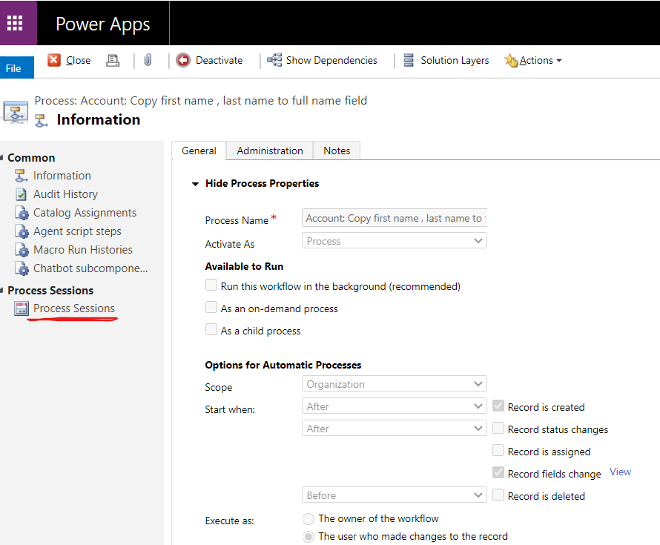

### Flow run history.

Run history includes a list of all executions that have occurred for a cloud flow. This data includes the flow’s status, start time, duration, and input/output data for triggers and actions. This run history gives the exact details of which step has failed or succeed.

Go to Flows solution -> open the flow. In the page as shown below, you will find the run history.

Either an end user or an administrator, who has been granted access to the flow through the Power Automate admin center, can follow these steps to export flow run history

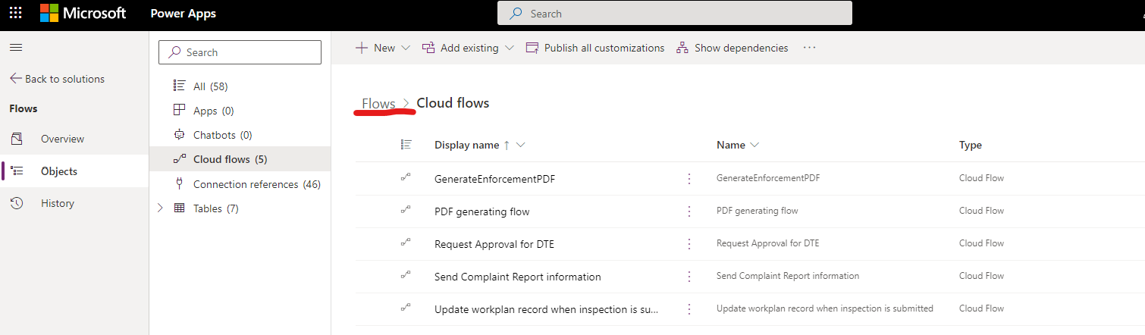

Figure 8 Flows Solution

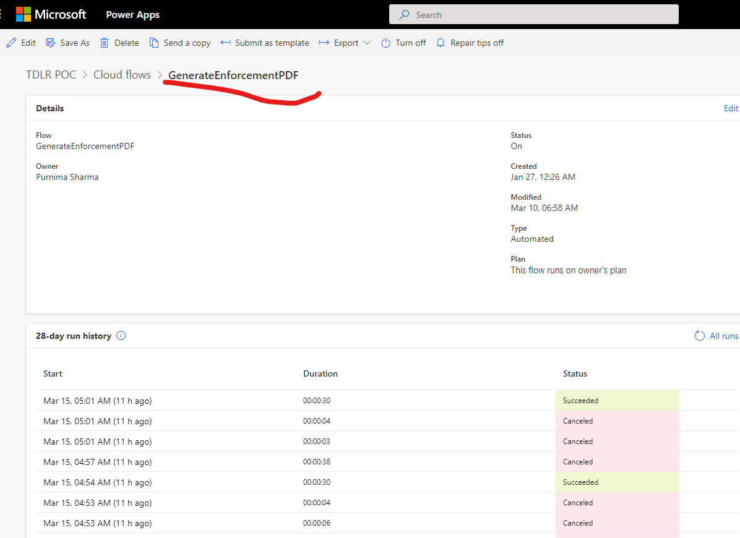

Figure 9 Flow run history of GenerateEnforcement PDF Flows

**Note:  
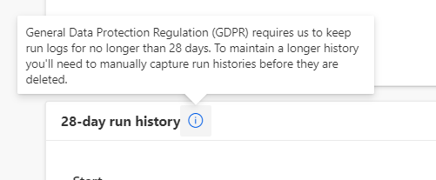**

#### Export Run History

Microsoft Flow has always had a highly detailed history view, where you can click on a single flow run and see exactly which steps have succeeded or failed. However, if you have a large number of flow runs, it can be difficult to find a specific failure. Now, you can Download a CSV of your flow run history and use Excel (or any other tool) to search across all of your flow runs, see exactly when they happened, and even the inputs and outputs of most steps.

Either an end user or an administrator, who has been granted access to the flow through the Power Automate admin center, can follow these steps to export this data:

1. Sign into Power Automate.
2. Select the **My flows** link, and then select the flow for which you want to export the run history.
3. In the **RUN HISTORY** pane, select **See all**.

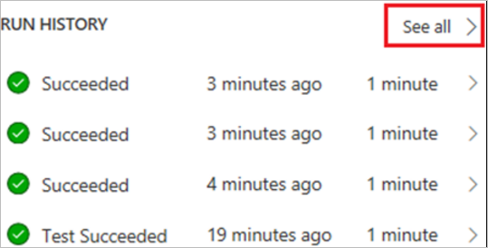

1. Select **Download CSV**.

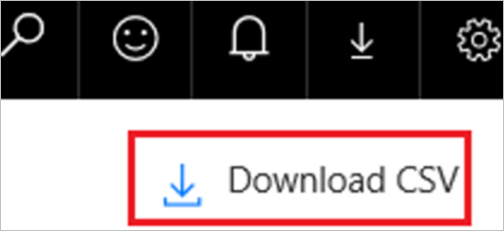

The run history is downloaded as a .csv file so that you can open it in Microsoft Excel or a text editor and further analyze the results.

# Appendix B: Dataflows for 2 way integration between Power Platform to and from VERSA and Tulip

**Overview of Standard DataFlows**: <https://docs.microsoft.com/en-us/power-query/dataflows/understanding-differences-between-analytical-standard-dataflows>

**On-premise data gateway**: <https://docs.microsoft.com/en-us/data-integration/gateway/service-gateway-onprem>

**Importing and exporting data:** <https://docs.microsoft.com/en-us/power-apps/maker/data-platform/import-export-data>

**Data Export Service:** https://docs.microsoft.com/en-us/power-apps/developer/data-platform/data-export-service

### 

### Connect from Tulip to Power Platform eInspections

1. Choose SQL Server as the Datasource:

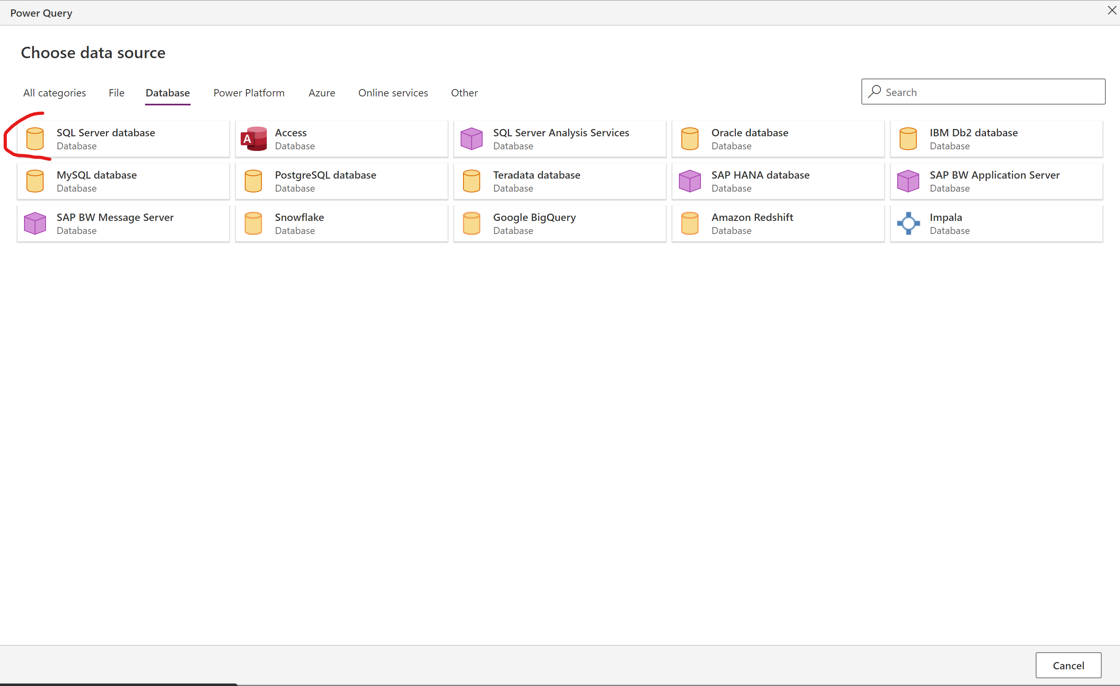

1. Connect with SQL Credentials

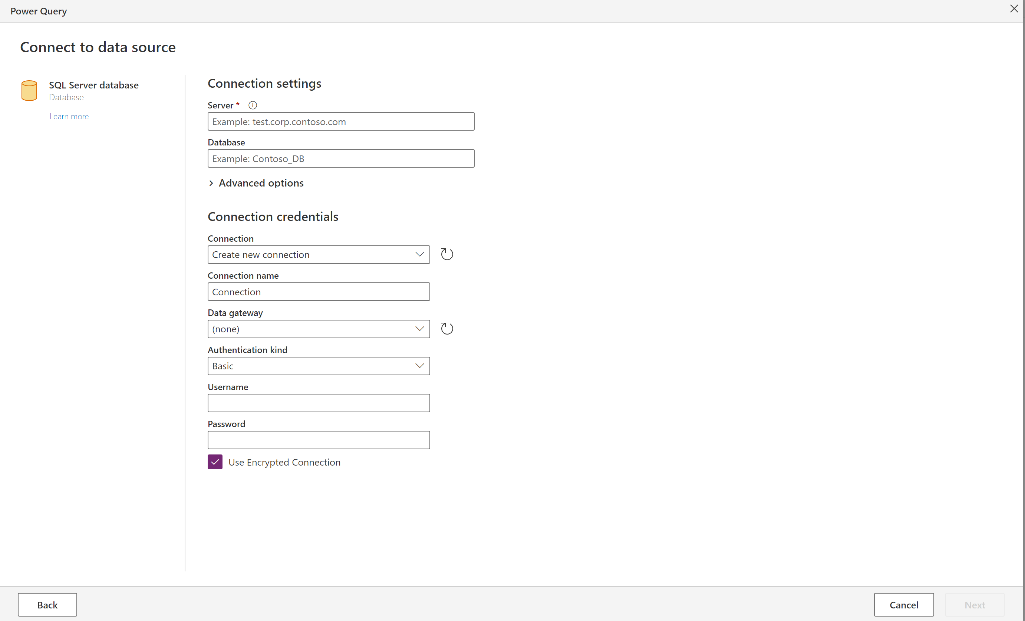

1. Do Transformations as necessary

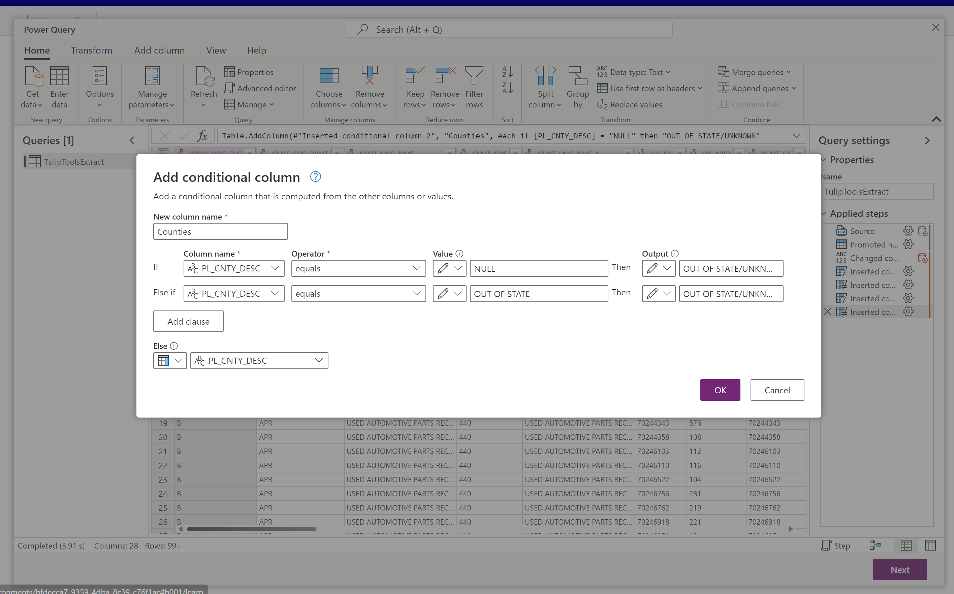

1. Map to appropriate table in eInspections

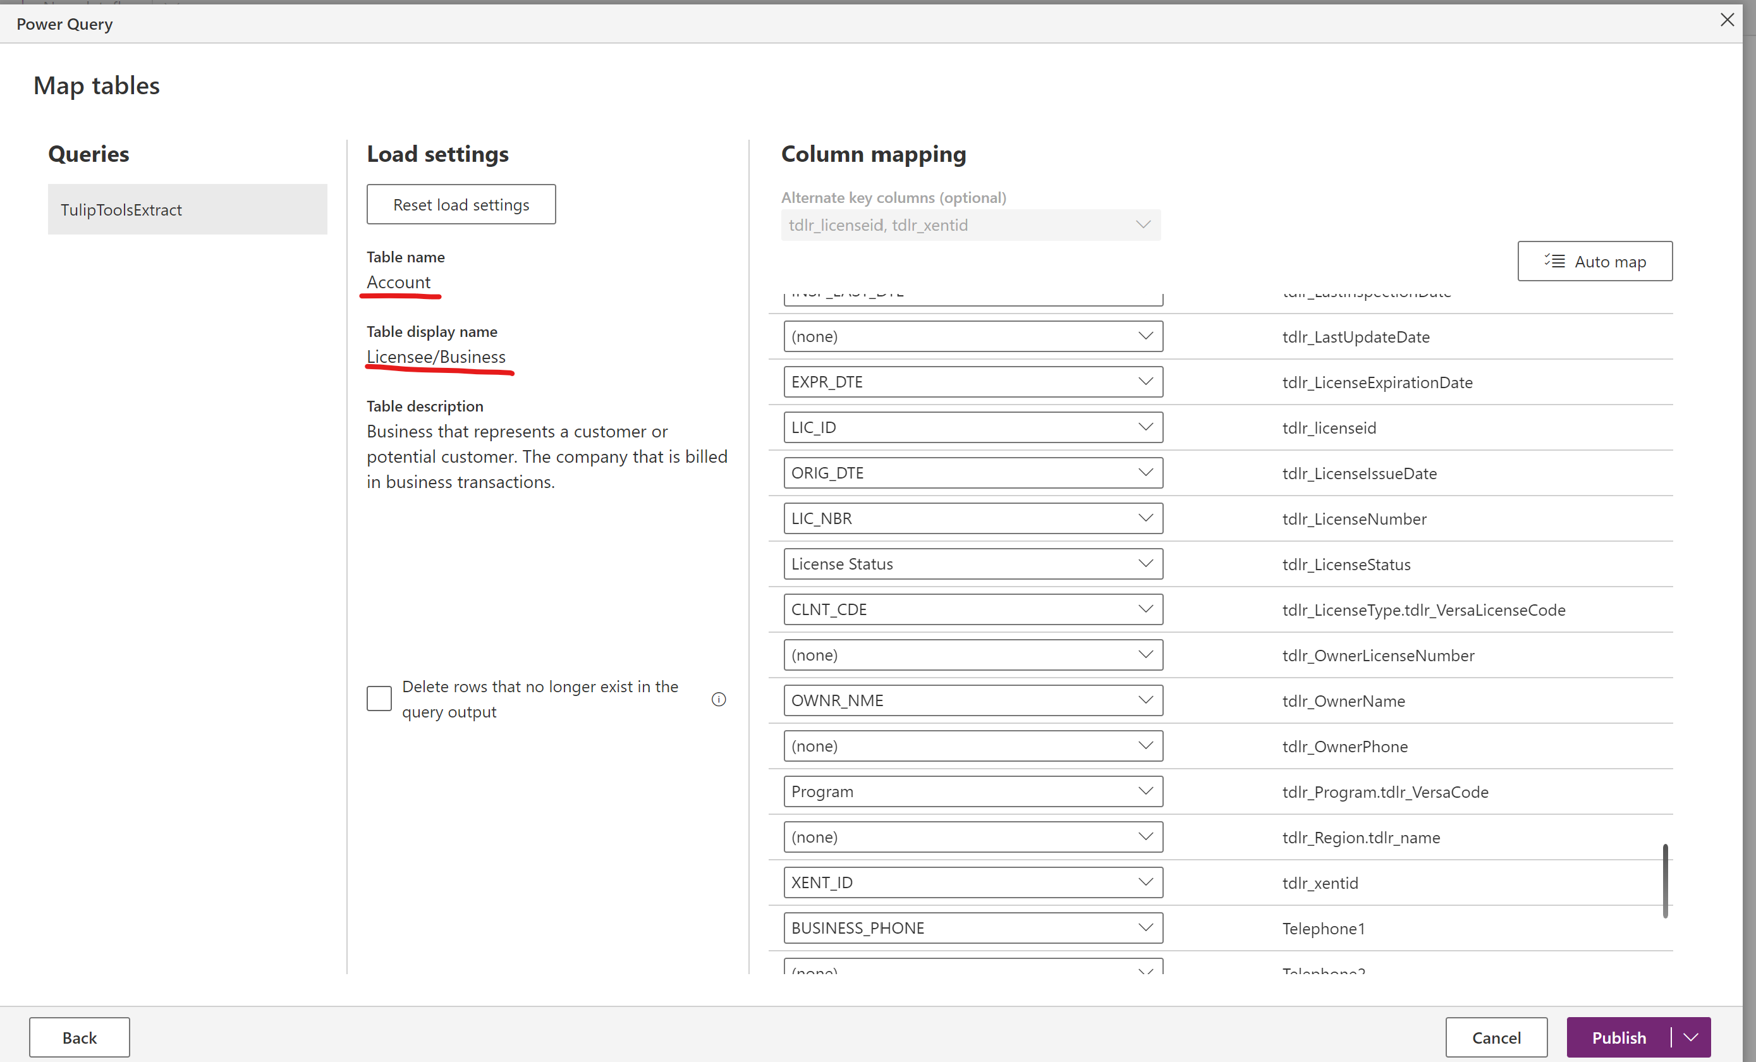

### Connect from VERSA to Power Platform eInspections

1. Choose Oracle database as the Datasource:

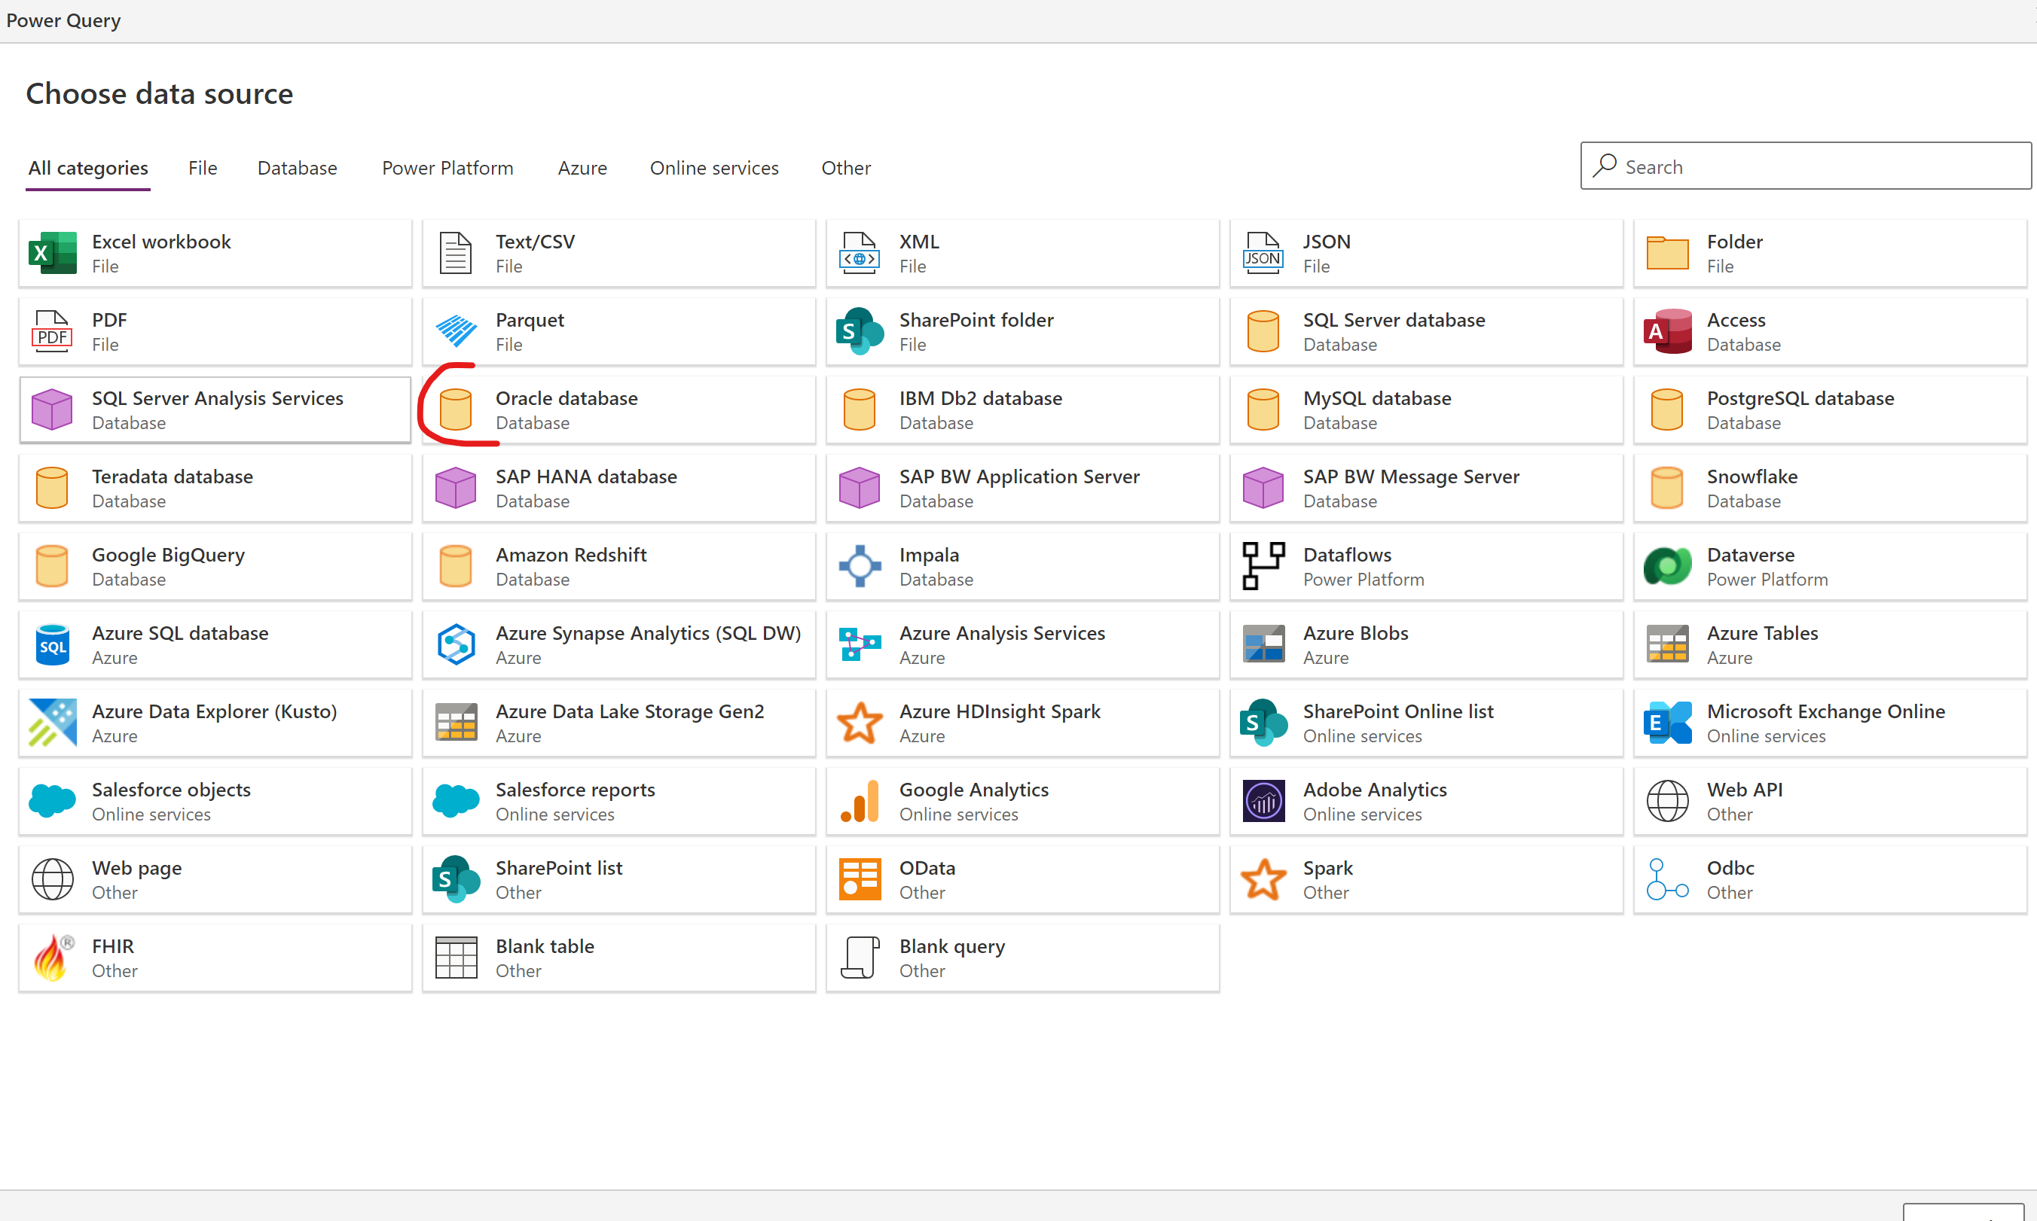

1. Connect with Oracle Credentials and on-Premise data Gateway

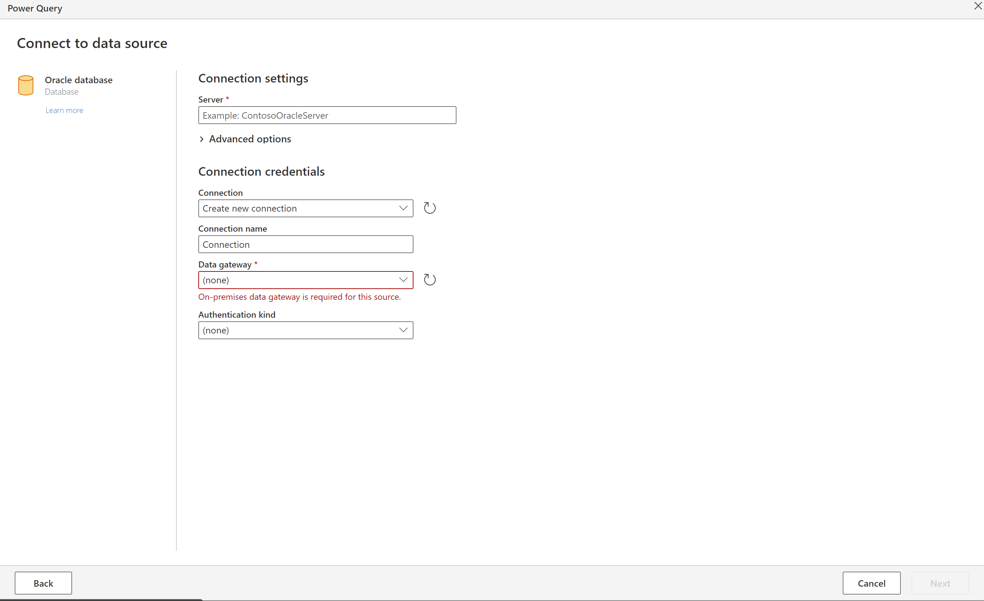

1. Do Transformations as necessary

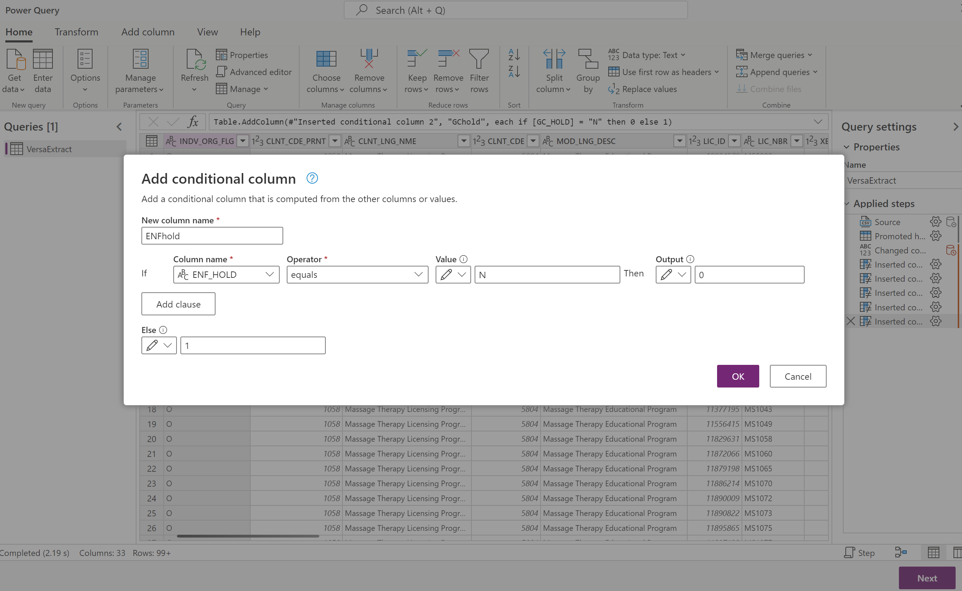

1. Map to appropriate table in eInspections



### Exporting Data from eInspections

Exporting data, either to another data technology or to another environment, you can use dataflows, Data Factory, Power Query, and Power Automate.

Dynamics customers who are targeting SQL Server or Azure SQL Database can use the Data Export Service.

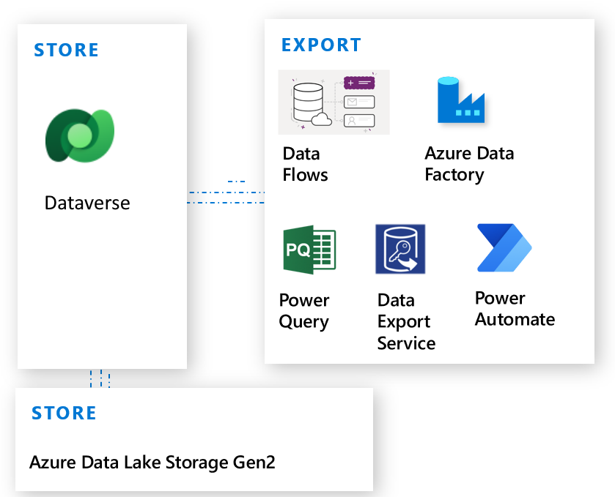

**Data Flows**

1. Choose Power Platform> Dataverse as the source:
2. Login with appropriate credentials and select environment: TDLR eInspections Dev, Test or Prod as appropriate.
3. Select account table(this is the Licensee table) and then the applicable columns

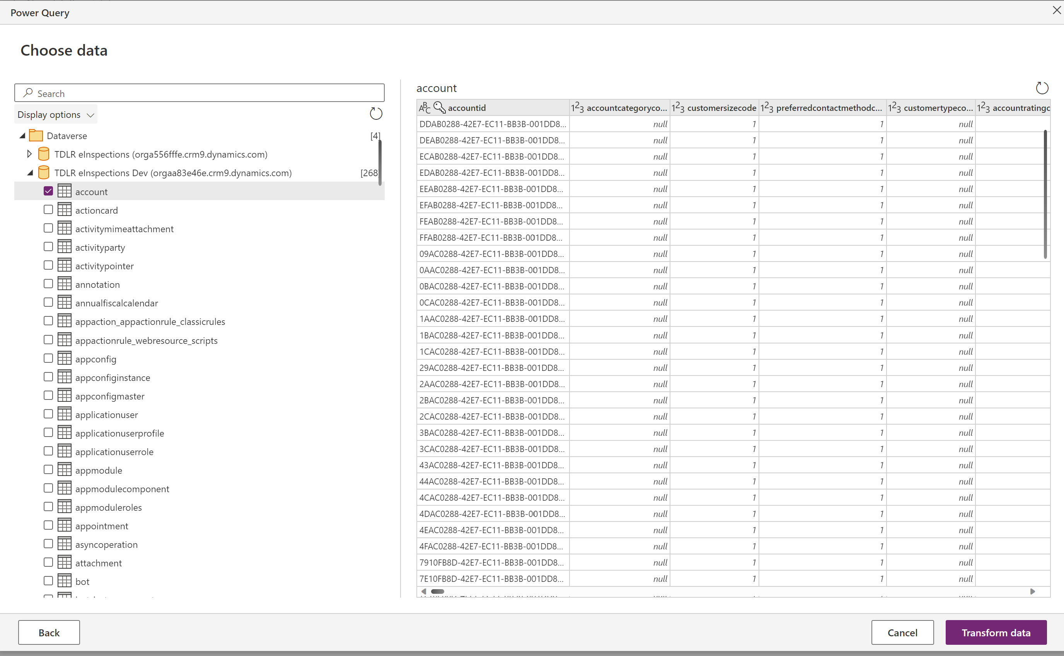

# Appendix B: References

### 9.1 Tools

* Dynamics 365 SDK ([https://docs.microsoft.com/enus/dynamics365/customerengagement/on-premises/developer/download-tools-nuget)](https://docs.microsoft.com/en-us/dynamics365/customerengagement/on-premises/developer/download-tools-nuget)
* Developer Tools ([https://docs.microsoft.com/enus/dynamics365/customerengagement/on-premises/developer/developer-tools)](https://docs.microsoft.com/en-us/dynamics365/customerengagement/on-premises/developer/developer-tools)
* Visual Studio and .Net Framework ([https://docs.microsoft.com/enus/dynamics365/customerengagement/on-premises/developer/visual-studio-dot-netframework)](https://docs.microsoft.com/en-us/dynamics365/customerengagement/on-premises/developer/visual-studio-dot-net-framework)
* XRM Toolbox

<https://www.xrmtoolbox.com/>

## Dynamics CE/ Dataverse

* Customize Dynamics 365 Customer Engagement Applications[(https://docs.microsoft.com/enus/dynamics365/customerengagement/on-premises/developer/customizedev/customize-applications)](https://docs.microsoft.com/en-us/dynamics365/customerengagement/on-premises/developer/customize-dev/customize-applications)
* Introductions to Solutions ([https://docs.microsoft.com/enus/powerapps/developer/common-data-service/introduction-solutions)](https://docs.microsoft.com/en-us/powerapps/developer/common-data-service/introduction-solutions)
* Maintain Managed Solutions ([https://docs.microsoft.com/enus/powerapps/developer/common-data-service/maintain-managed-solutions)](https://docs.microsoft.com/en-us/powerapps/developer/common-data-service/maintain-managed-solutions)
* Add Dynamics 365 Instances to Microsoft 365 Subscription [(https://docs.microsoft.com/enus/dynamics365/customer-engagement/admin/add-instancesubscription#BKMK_man_sec_group)](https://docs.microsoft.com/en-us/dynamics365/customer-engagement/admin/add-instance-subscription#BKMK_man_sec_group)
* Manage Dynamics 365 Online Instances [(https://docs.microsoft.com/enus/dynamics365/customer-engagement/admin/manage-online-instances)](https://docs.microsoft.com/en-us/dynamics365/customer-engagement/admin/manage-online-instances)
* Manage Dynamics 365 Sandbox Instances [(https://docs.microsoft.com/enus/dynamics365/customer-engagement/admin/manage-sandbox-instances)](https://docs.microsoft.com/en-us/dynamics365/customer-engagement/admin/manage-sandbox-instances)
* Manage Dynamics 365 Instance using Dynamics 365 Service Administrator

[(https://docs.microsoft.com/en-us/dynamics365/customer-engagement/admin/useservice-admin-role-manage-tenant)](https://docs.microsoft.com/en-us/dynamics365/customer-engagement/admin/use-service-admin-role-manage-tenant)